5 Signs Your Business Problem Is a Perfect Fit for an AI Solution (And 3 Signs It Isn't)

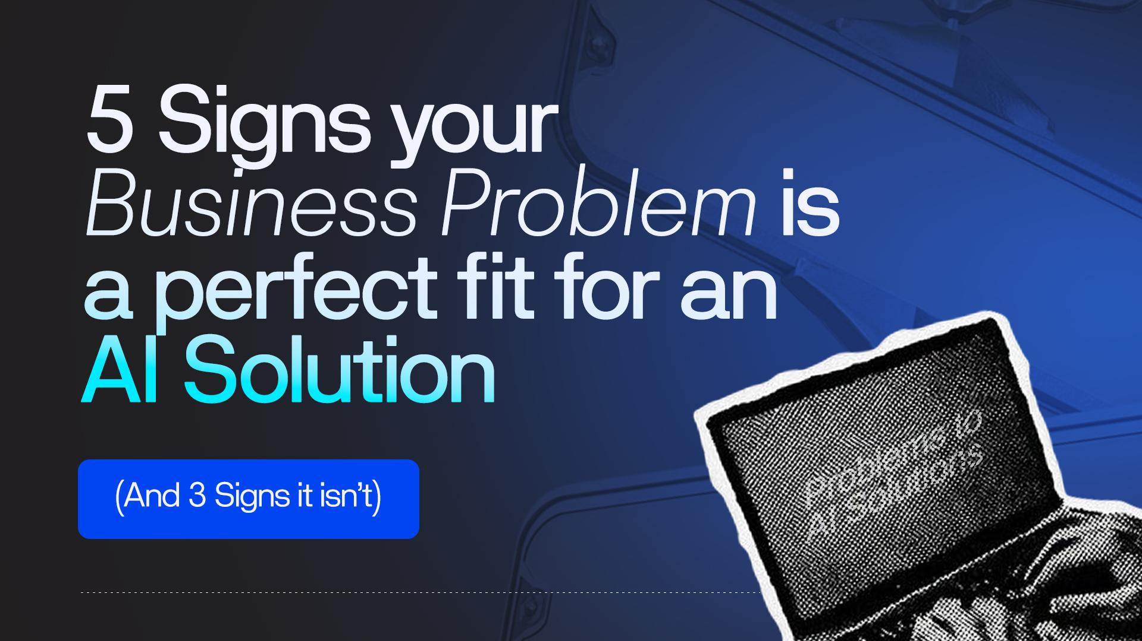The Question That Should Come Before Every AI Decision
Somewhere between the hype cycle and the horror stories, there is a more useful question most businesses never ask before investing in AI.
Not: 'What can AI do?' Not: 'Which AI tools are the best?' But simply: 'Is my problem actually a good fit for AI?'
It sounds obvious. In practice, it almost never happens. Kovair's 2024 analysis of AI project failures found a consistent pattern: companies adopt AI because a competitor is using it, a vendor is pitching it, or a board member asked about it, not because they mapped a specific business problem to a specific AI capability. That mismatch is the single most reliable predictor of project failure.
This framework exists to close that gap. Below are the five signals Zeffron has identified that verify your business problem is a strong AI candidate, and three signals that tell you it isn’t, at least not yet. At the end, you’ll find a 60-second self-assessment you can run right now.
"The problem is not the technology. The problem is fit. Many companies adopt AI because they feel they should." — Kovair Business AI Analysis, 2024

The 5 Green-Light Signs: Your Problem Is a Good AI Fit
🟢 Sign 1: You Have a High Volume of Repetitive, Rule-Bounded Tasks
This is the most reliable indicator of AI fit. If your team is doing the same cognitive work over and over, with the same inputs, the same decision rules, and the same outputs, AI can almost certainly help.
The test: Could a thoughtful new employee learn to do this task accurately from a written procedure? If yes, AI can likely learn it too. High-volume customer query routing, invoice classification, document data extraction, and standard report generation — these are all strong candidates.
A logistics company processing thousands of freight invoices weekly is spending human attention on a task that has clear, learnable rules. That's a green light. An e-commerce brand handling 2,000 customer support emails a day, 70% of which fall into five question categories, is another.
Green-light check: If this task disappeared tomorrow, would you immediately need to hire someone? If yes, AI may be able to fill exactly that capacity gap.

🟢 Sign 2: You Have High-Volume Customer Queries With Predictable Patterns
Customer-facing query automation is one of the highest-ROI AI use cases in 2025, according to TTMS enterprise research. The key qualifier is predictability. If your customer queries cluster around a bounded set of intents, order status, policy questions, troubleshooting steps, and booking changes, AI handles this well.
The signal to look for: If your customer service team has an informal 'FAQ mental model', the questions they answer by memory- that is a strong indicator that AI can be trained to handle those same pathways.
Klarna is one of the clearest examples of this in practice. The fintech company’s AI assistant took over two-thirds of all customer service chats, handling over 2.3 million conversations and performing the equivalent workload of 700 full-time agents, delivering an estimated $40 million profit improvement in 2024 (NexGen Cloud, 2025). The problem Klarna solved wasn’t complex; it was high-volume and pattern-rich. Customer queries, at scale, with clear inputs and predictable outputs. That’s the green-light profile. And the financial impact followed directly: cost-per-contact dropped, agent time shifted to higher-value work, and what had been a support cost centre became a measurable driver of profit improvement.
Where this breaks: if every customer situation is genuinely unique and requires novel judgment, pure AI automation will frustrate users. A hybrid model, AI handles tier-1, humans escalate tier-2, often works better.

🟢 Sign 3: You're Sitting on Large Amounts of Unstructured Data That Nobody Has Time to Analyse
Data that exists but goes unanalysed is latent business intelligence, and it's one of the highest-leverage AI opportunities. Sales call recordings, customer feedback forms, support transcripts, internal reports, maintenance logs: if you have years of structured or unstructured data and no capacity to extract patterns from it, AI can create value immediately.
A concrete example: Many sales teams record every call. Almost none of them review more than a fraction of those recordings. AI-powered sales intelligence tools can scan the entire library, flag talk-ratio patterns, identify objections that correlate with deal loss, and surface coaching opportunities at scale, work that would take a human analyst months to do manually.
The McKinsey Global Survey (2025) found that the sharpest AI-driven growth was in IT and sales functions, precisely because those departments generate dense, structured interaction data that AI can process efficiently.
🟢 Sign 4: You Need Decisions Made From Patterns Across Large Datasets
Some business decisions are genuinely pattern-recognition problems at scale. Demand forecasting, fraud detection, churn prediction, predictive maintenance: these are tasks where a human simply cannot hold enough variables in their head simultaneously to match what a well-trained model can do.
If your team is already making decisions that rely on historical data and trend analysis, but the process is slow, inconsistent, or happens too infrequently to be useful, AI can systematise and accelerate that judgment.
A global logistics firm that implemented AI-driven demand forecasting was able to proactively manage inventory levels, reduce overstock, and minimise stockouts, because the model could process demand signals across its entire network simultaneously. No human analyst team could match that speed at that scale.
The signal here: you already know the decision you want to make faster or more accurately. You just don't have the analytical bandwidth to make it well, at volume, consistently.
🟢 Sign 5: Your Process Has Clear, Testable Inputs and Outputs
AI systems are significantly easier to build, validate, and trust when the problem has a well-defined input, a knowable output, and a way to measure whether the output is correct. Classification tasks, scoring models, extraction jobs, and routing systems all meet this bar.
This is the underrated criterion. If you cannot define what 'correct' looks like for a given output, you cannot evaluate whether your AI is performing. Ambiguous success criteria are a warning sign, not because the problem is wrong, but because the scoping work hasn't been done yet.
Before any AI build begins, we ask clients: 'If the AI processes 1,000 records this week, how will you know whether it performed well?' If the answer is clear and measurable, the project has a strong foundation.

The 3 Red-Light Signs: Your Problem Isn't a Good AI Fit Right Now
This section is as important as the green lights. Not every business problem should be solved with AI. The following three patterns are consistent indicators of poor fit, and proceeding without addressing them is a reliable path to a failed project.

🔴 Sign 1: The Problem Requires 100% Accuracy, and There Is No Tolerance for Error
AI systems are probabilistic. They are right most of the time, but not all of the time. For use cases where any error creates significant harm, such as final medical diagnoses, binding legal decisions, and safety-critical control systems, AI should not be the decision-maker. It can assist, but a human must own the outcome.
This is also true for high-stakes financial transactions, compliance filings, and any context where the cost of a single mistake exceeds the value AI creates in aggregate. The failure mode isn't hypothetical: Taco Bell's voice AI deployment in 500+ drive-throughs generated viral complaints because it struggled with accents, background noise, and edge cases — and 'sometimes it surprises me' was not an acceptable standard for customer experience.
Red-light check: If an AI error in this process would trigger a regulatory penalty, a safety risk, or a serious customer harm, AI is at best a co-pilot here, not the decision-maker.

🔴 Sign 2: The Data Doesn't Exist Yet, or It's in No Condition to Be Used
This is the most common reason AI projects fail silently. A model trained on bad data makes bad decisions. A business that doesn't have sufficient historical data for the pattern it wants to learn cannot shortcut that requirement with a clever algorithm.
A 2025 Hyperscience and Harris Poll study found that 77% of organisations underuse the data they already have. Frequently, the issue isn't that the data doesn't exist at all — it's fragmented, inconsistently labelled, stored in incompatible systems, or simply never collected in a structured way.
This is not a permanent red light. It is a sequencing signal. Data infrastructure work comes first. Once the data exists, is clean, and is accessible, the AI layer becomes far more tractable.
Red-light check: Could you run a report answering your core question today, even manually? If no, there's foundational data work to do before an AI project makes sense.

🔴 Sign 3: Human Empathy Is the Core Value Being Delivered
Some business interactions derive their value specifically from the presence of a human. Grief counselling, complex negotiation, executive relationship management, high-stakes creative collaboration: these are not AI problems. They are human problems.
The test: would your customer feel the quality of the interaction drop significantly if they knew it was AI? If yes, that is important information. AI can support, prepare, and summarise around these interactions, but it should not front them.
This is also true of tasks where accountability matters. If someone must own the outcome personally, and that personal accountability is part of what makes the outcome valuable, AI cannot substitute for that responsibility.
Interestingly, this is a signal of market positioning, not just a technical limitation. Businesses that are clear about where human judgment is irreplaceable build more trust with clients than those that try to automate everything.

The 60-Second Self-Assessment
Run through the following questions for the specific business problem you're considering. Answer yes or no. Be honest, the value is in the accuracy of your assessment, not the score you want to have.
Green-Light Questions:
✓ Is this task performed more than 50 times per week?
✓ Could a new employee learn to do it accurately from a written procedure?
✓ Do you have at least 12 months of historical data related to this process?
✓ Can you define what a 'correct' output looks like?
✓ Would reducing errors or processing time here create measurable business value?
Red-Light Questions:
✗ Does a single error in this process cause significant harm or regulatory risk?
✗ Is the data you'd need to train or run this system unavailable or unreliable?
✗ Is human presence itself a core part of what makes this interaction valuable?
Scoring guide: If you answered yes to 4 or more green-light questions and no to all red-light questions, your problem is likely a strong AI candidate. If you answered yes to any red-light question, address that constraint first; it will determine the shape of any viable solution.

What to Do With Your Score
If you scored well on the green lights, the next step is to scope the problem precisely: quantify the volume, map the current workflow, assess the data quality, and define the success metric. That work determines everything downstream.
If you hit a red light, that isn't a dead end. It's a sequencing question. Data infrastructure might need to come first. A human-in-the-loop design might make a 100%-accuracy requirement solvable. Mapping the workflow might reveal that one part of a larger process is a strong AI candidate, even if the whole isn't.
Either way, this is exactly the conversation we have in discovery. If you've run through this framework and want to pressure-test your assessment with a team that does this every day, book a call.
If your self-assessment is pointing toward a green light, the next move is a focused 30-minute AI Fit call with the Zeffron team. We’ll review your specific workflow, tell you honestly whether it’s a strong AI candidate, outline what a first build would realistically look like, and flag any data or infrastructure gaps before they become expensive surprises. No pitch deck. No obligation. Just a clear, expert read on whether AI is the right call for your business — and what to do next if it is.
→ Book your free AI Fit call at zeffron.com/fit-assessment

